Project Report

File System Implementation
CSE2005 – Operating Systems
Slot – L11+L12

Submitted by
Madhur Dixit – 17BCE2181
S. Mahika Rao – 17BCE0944
Shiwam Kumar Jaiswal – 17BCE2371
Ranveer Raj Dhakal – 17BCE2360
Adarsh Shankar – 17BCE2204

Under the guidance of
Prof. P.Gayathri

Bachelor of Technology
in
Computer Science and Engineering



School of Computing Science and Engineering

October 2018

- Abstract:

- Keywords:
File allocation system, File allocation tables(FAT), Contiguous allocation, Linked list allocation, Architecture, Combination of both, Impact on efficiency, Parameters of FAT.

- Introduction:
The FAT file system is responsible for maintaining the data in the memory and used for data feeding and retrieval from the memory. File allocation tables are responsible for the address which is used for data retrieval. There are two methods of data feeding in the memory. In out project we are using both the ways for data feeding in the memory for a better file management with a faster access if required. The user is given the choice of the method the user likes. If the user prefers memory management, they can go for linked file allocation otherwise they can go for contiguous file management. Two copies of the table are made to get a backup in case of file corruption. The size of the cluster is pre defined by the system unless more size is needed.
- Literature Survey:
- Gaps Identified and Observations made from the Literature survey:
Generally File Allocation Tables are implied using two methods. The two methods being Contiguous and linked and this information was supported by the literature survey mentioned above
As a coin these both systems have both pros and cons which are hereby elaborated in this document:
The Contiguous file allocation system is the method in which the files are stored in memory with side by side address in a contiguous manner. Due to this the traversal is very fast as the computer targets the memory using it address. By only knowing the start of file we can access other files too and that makes the remembering for the system easy. High performance because only one address is used for finding the required file.
It comes with some problems like of external fragmentation in an event of file deletion. When a file is deleted a chunk of memory in between is left null. Which causes loss of memory. So whenever a file is deleted the disk becomes broken with spaces in between and to solve that problem we have to do disk compaction. The application of compaction in a memory is really expensive and thus this is a drawback.
In the Linked List File Allocation System the system allocates files to the memory and then they allocate a pointer to each memory. So when a file is allocated, it is allocated with a pointer to next file to be added. And the new file is pointed by the previous file the system traverse file using pointers, moving from one file to another until it finds the file it is looking for. Another advantage is the file can be of variable size. We don’t have to define a size limit for the file.
The limitations of Linked Allocation is that direct access is restricted thus it is slow. If you have to access the last file then you have to go through every file. This causes a slow functioning of the machine. But no external fragmentation happens so there is no wastage of memory.
The gap we identified while working on literature survey was that most of the operating systems today use either contiguous FAT or linked list FAT in order to execute a task. However with our project, we wish to accomplish a file allocation system that uses the advantages of both and minimise the disadvantages presented individually to bring optimise the system to our best capabilities.

Proposed Models- Explanation of model with architecture:
The architecture of our file allocation system is simple and easy o understand. The two kinds of architecture that are used for File allocation systems are contagious and linked.
Contagious Allocation is a solitary constant arrangement of squares which are divided for a document at the time of record creation. It is easy to enhance the I/O execution in such a situation for easy handling.

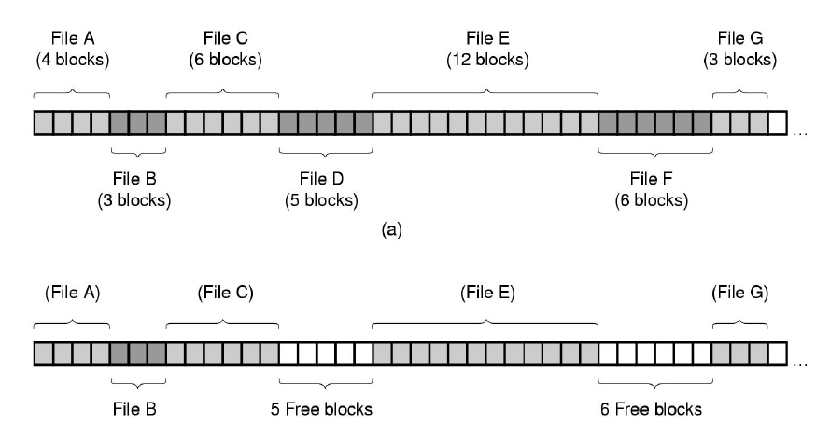
Linked Allocation is a non-contagious allocation. Each block contains a link to the next block. It links in both directions. It has no fragmentation and adding to a file is easy but its not suitable due to:
- i) Can’t be used for Random access
- ii) Additional disk head searching
- iii) Overhead in storing the pointers
- iv) Recovery of a defective Block is Difficult

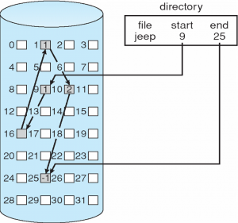
Hence, we have kept all of this in mind while creating our new code.
Our new code is written in C language so it’s simple and easy to understand. And hence overall our model is a simple one with a innovative new idea.

- Results obtained:
- Performance evaluation:
Parameters identified for evaluation of proposed model
The proposed model is basic implementation of file system. The parameters for evaluation of the file system are:
- Creating a file
- Deleting a file
- Printing the contents of the file
- Displaying the file allocation table
- Displaying the block details.
Creating a new file:
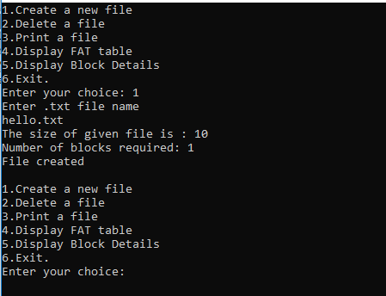

Displaying the FAT table after the creation of the file
It contains of the name of the file, its size and its contents.
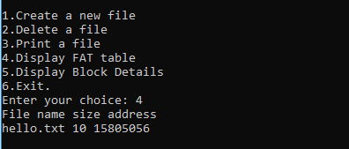

Delete the file.
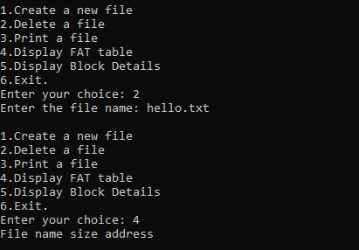
Displaying the FAT table again which is empty, this indicates that the file is deleted.

- References:

